1. Design TM using simulator to accept the input string anbn

INPUT:

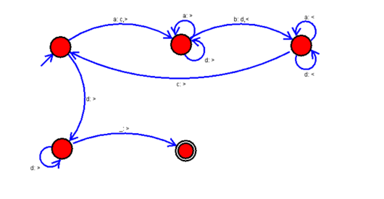

OUTPUT:

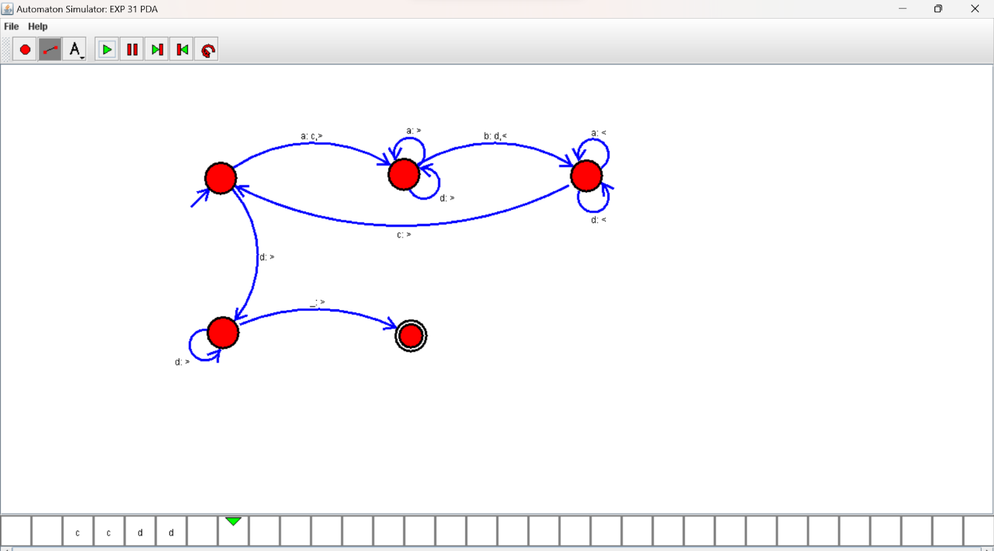

RESULTS:

TM using simulator to accepting the input string anbn